installed node and nodejs

set path

export #PATH

can know by which node

which npm

for keybase dependencies : then in keybase.io

followed steps using LINUX and ran commands

curl -O https://prerelease.keybase.io/keybase_amd64.deb

# if you see an error about missing `libappindicator1`

# from the next command, you can ignore it, as the

# subsequent command corrects it

sudo dpkg -i keybase_amd64.deb

sudo apt-get install -f

run_keybase

then

keybase login

enter username passwd device

login successful

now cross check keybase pgp list (after key is generated)

keybase cred :

username  : susritha / pwd susritha / email id : gmail id / devicee : Terraform

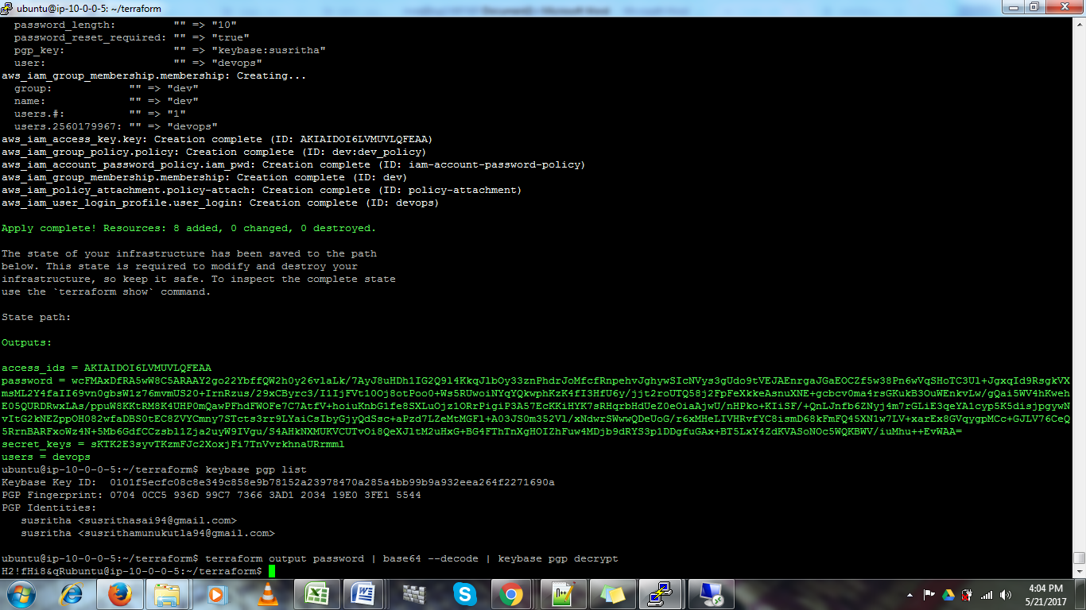

<https://keybase.io/docs/the_app/install_windows>

Its possible to get console password for IAM USER using terraform :

Using below command :

terraform output password | base64 --decode | keybase pgp decrypt

Follow below instructions :

1.Store password in outputs.tf file

2.terraform output password > would give your encrypted password

3. Now before install nodejs and node on your server and set PATH

4.Now to decrypt password we need one more concept that is KEYBASE :

https://keybase.io/

4. Go this site

create a account in KEYBASE from consolethen under Docs go to Linux/Ubuntu and follow instructions :

Now in shell

keybase login

enter all details.

5. Point to be noted :

resource "aws_iam_user_login_profile" "user_login" {

user = "${aws_iam_user.user.name}"

pgp_key = "keybase:username" ------------ username means: user you created in keybase account

password_length = 10

}

Now terraform plan

terraform apply

keybase pgp list

terraform output password | base64 --decode | keybase pgp decrypt

You would get your password :) :)